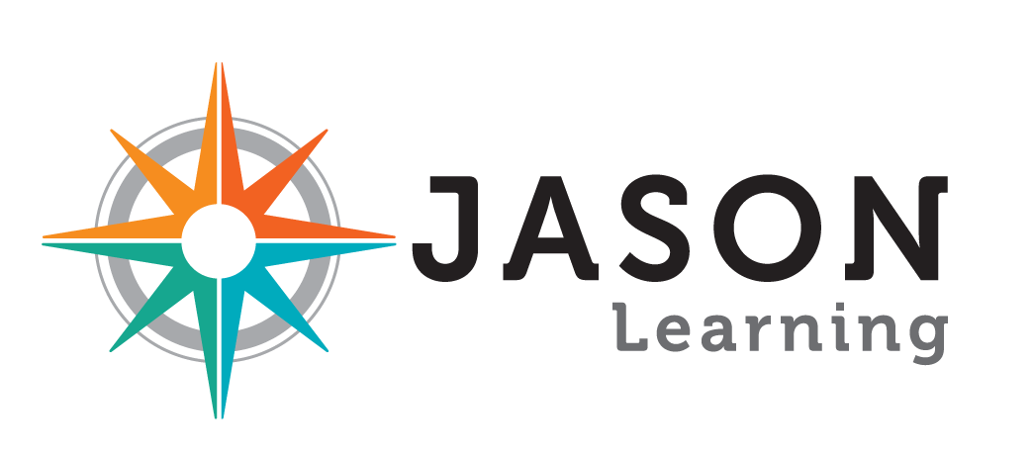
STEM Career Role Model Profile

Please fill in as much information as you care to. None of the items are required, but the more you share the better our students will know you and relate to you. Thanks in advance for your willingness to share your story!

Basic Bio
Question | Answer
Name
What are your favorite hobbies or activities you do for fun?

Do you play any musical instruments?

Do you play any sports or do any athletic activities?

What is your favorite non-science book, magazine, or blog?

What’s the most frequently played song on your mp3 player (or other music-playing device)?

Who do you look up to and admire?

Education
Question | Answer
Highest degree attained
Future degree(s) planning on pursuing, if any

Schools attended
Favorite classes/coursework in elementary school, middle school, high school, college
What educational accomplishments are you most proud of?
What kinds of challenges did you overcome during your education?

Current Career
Question | Answer
Employer
Official title
“Layman’s” title (ex: biologist)
Years in this organization/position
What does your organization do?
What is your role in the organization?
Describe your work environment

What tools and/or techniques do you use in your job?

Describe a typical day in your job

Describe an atypical (but notable) day in your job
How is the work you do important to society?

What accomplishments are you most proud of in your current role?

What projects or goals are you currently pursuing?

What are the biggest challenges you face in your work?
What is the most exciting, most amazing, or scariest thing that has happened to you during your work?

Career Path
Question | Answer
Previous employers and positions that have lead to your current role

Other positions not necessarily related to your current career

Best job you’ve ever had and why
Worst job you’ve ever had and why
What were you like as a kid?

What were your favorite books/shows/movies when you were a kid?

What did you think you were going to be when you grew up at age 12? At age 15? At age 18?
When did you know you wanted to pursue your current career, and what drove you towards it?

Who inspired you on this path?

What did you believe about this career before entering into it that proved to be different once you were in?

If you weren’t doing what you’re doing now, what other career(s) might you have pursued?

Additional Information
Question | Answer
What advice would you give a student interested in pursuing your career?

What advice would you give students in general?

What are some interesting places you’ve traveled? (Can be career-related or personal.)

Available Resources
Question | Answer
Please note any photos, videos, publications, links or other resources that we can share with our students.

